Student’s name | …………………………………………………….…… | Grade | 5
Subject | Computer | Week No. | 5
Lesson Title | Wireless Communication | Unit
Worksheet No. ( 5 )

write the correct name of each part.
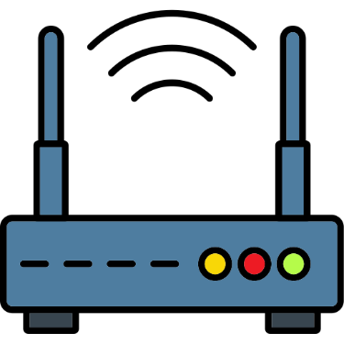


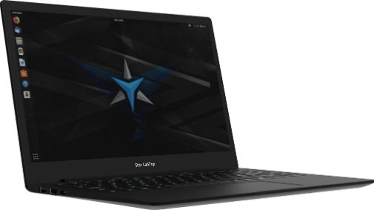
Good Luck

Bluetooth
Router
Laptop
NFC

